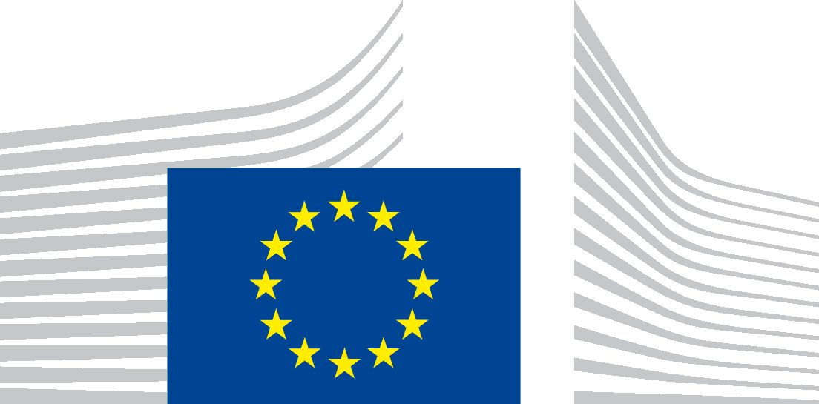 | EUROPEAN COMMISSION  DIRECTORATE-GENERAL  JOINT RESEARCH CENTRE  Directorate D - Institute for Reference Materials and Measurements  Standards for Nuclear Safety, Security and Safeguards
ACCESS FORM IRMM

Please provide us the following information to enable the organisation of your visit at JRC-IRMM

Surname / Family name :

First name :

Birthdate :

Place of Birth:

Nationality:

Identity card number / Passport number (bring it along for your visit at IRMM):

Company/Institution:

Email:

The data you are asked to submit will be used in connection with organising your visit at JRC-IRMM only. JRC-IRMM may use the data for mailing purposes. JRC-IRMM will not transfer your personal data to third parties. Photographs and audiovisual footage may be taken during the event and published thereafter. To delete your data from the database or if you do not agree to have your photograph and/or audiovisual footage taken and published by the JRC after the event, please send an e-mail to the JRC-IRMM contact person who organised your stay at JRC-IRMM. By sending the form you accept the conditions concerning the process of your data.

